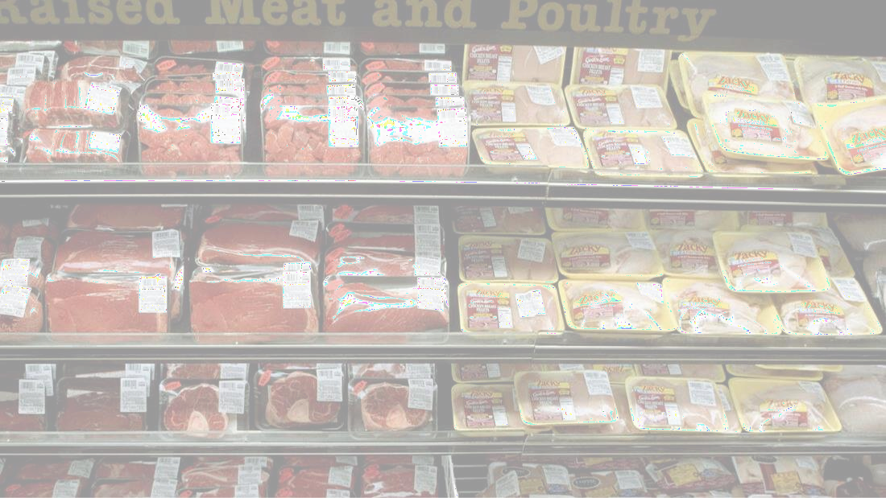



Kitchen Story

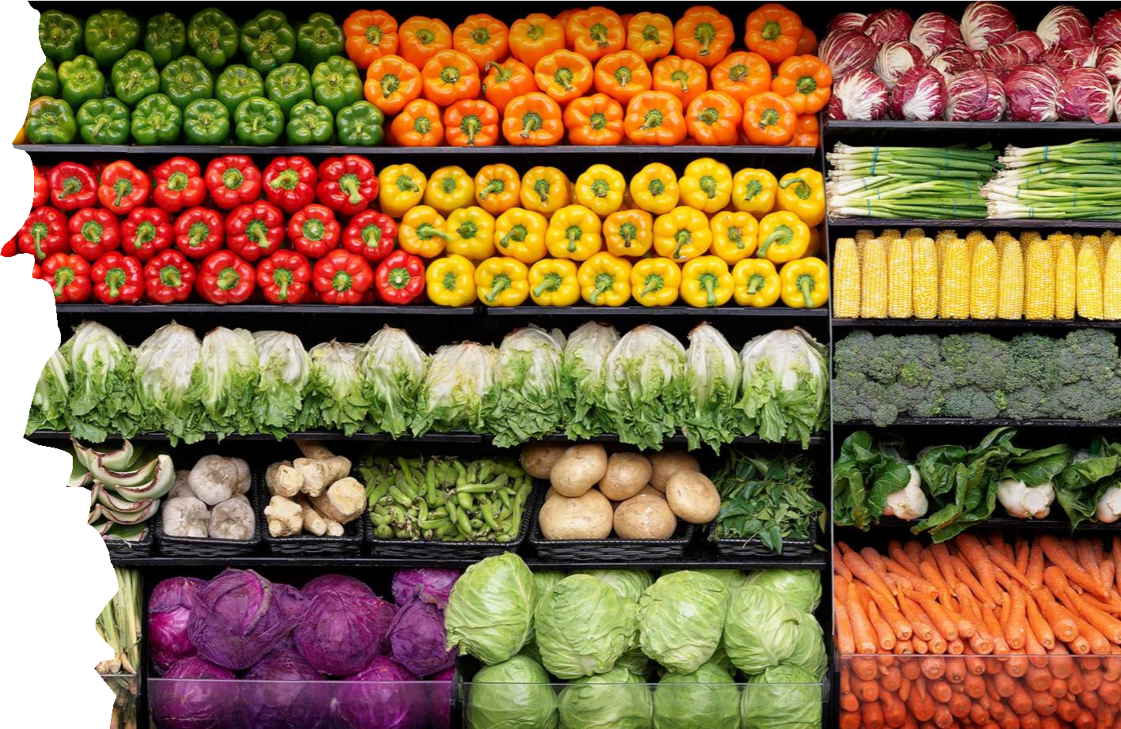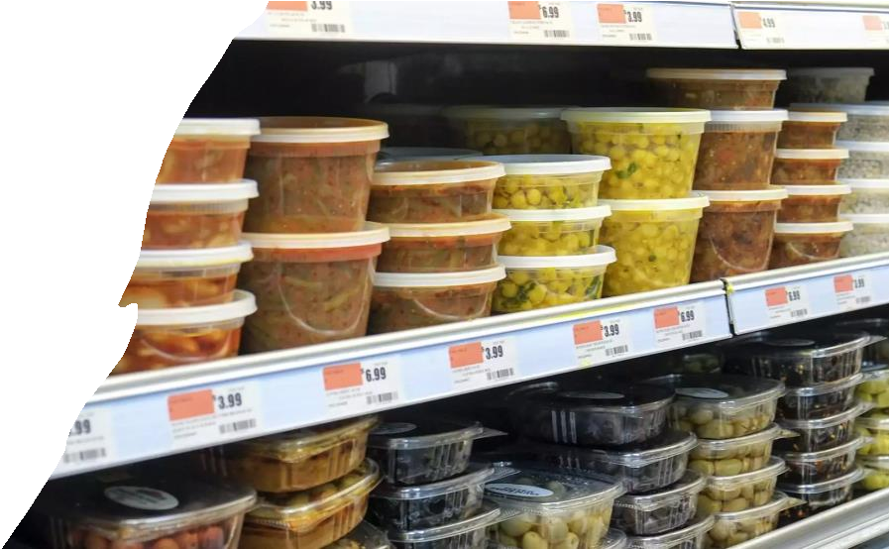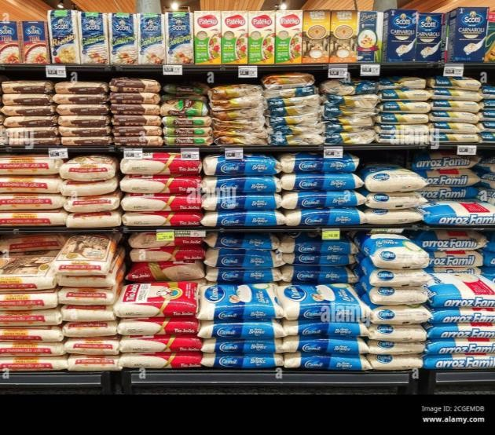**Phase 5 Frontend Project**

Ankita Asati

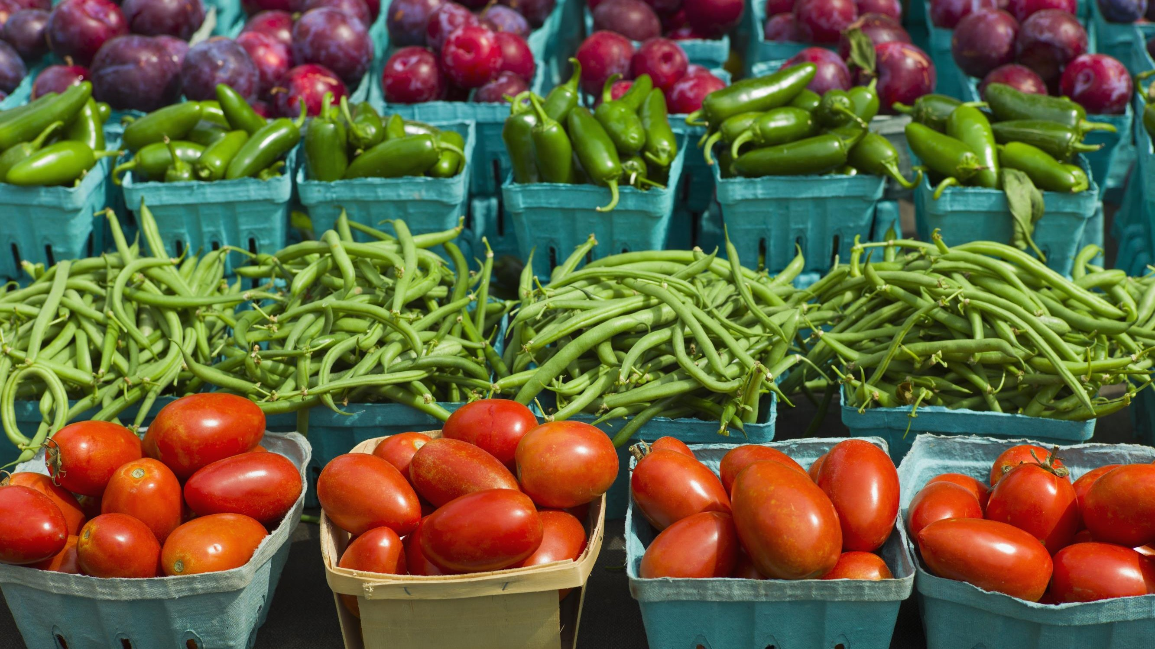

Project Overview



* **Kitchen Story** is an e-commerce portal that lets people shop for basic food items on their website using Angular. It enables users to search and buy the available products. You are not required to connect to a backend (i.e. Spring Boot). You can use JSON data or hard coded arrays for the application.
* Required Technical Components

IDE: Visual

Studio Code

Programming

Language: Angular

JSON

Bootstrap

* Optional Technical Components

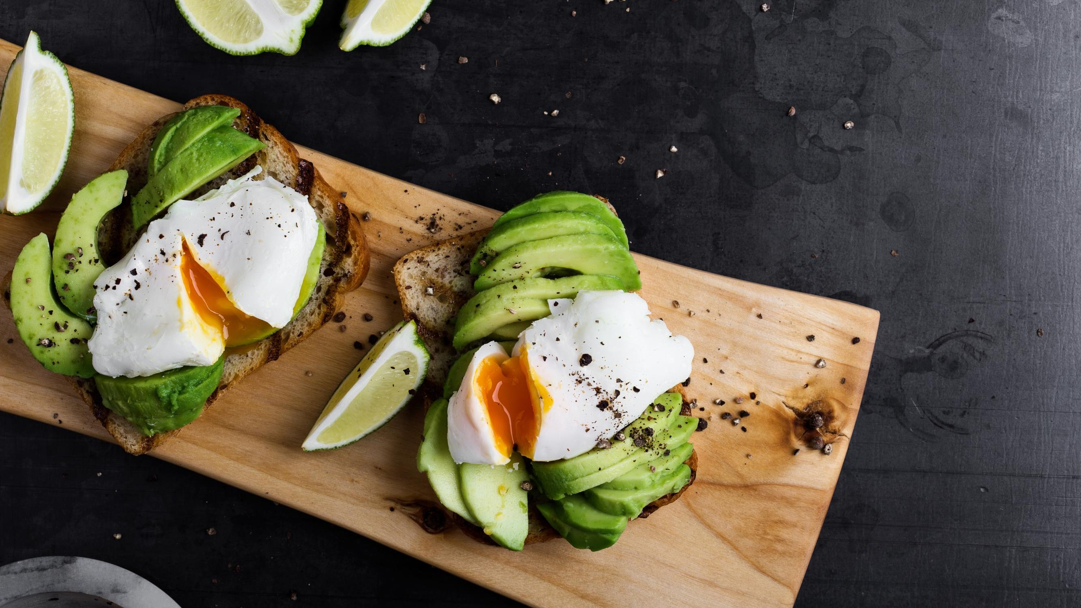



Core Concepts Demonstrated(page 1:2)

* **Angular Framework**
  + Demonstrate component-based architecture to build responsive single page

application

* + Interpolation & Dependency Injection
  + Implemented Angular Directives
    - Component
    - Structural (ngIf, ngFor)
    - Attribute (ngClass)
  + Implemented various types of binding
    - Property Binding
    - Class Binding
    - Style Binding
    - Binding to User Input Events
    - Two-Way Binding (forms)
  + Built-in and Custom Pipes
  + Defined services to implement business logic
  + Implement the Angular routing mechanism
  + Responsive Forms for User input and validation





Core Concepts Demonstrated(page 2:2)

* Implement **Node Package Manager (NPM)** via Node.js
* **Bootstrap**

### Utilized bootstrap design templates for some interface components

* **HTML**

### Used to create content for webpages

* **CSS**

### Used to format and style webpages (still working on developing these skills)

* **JSON Data**

### Hardcoded JSON data for each product, tag, and User in the Kitchen Story application

User Roles

**User/Customer that provides the following features:**

* A search form on the home page to allow entry of the food items to be purchased by the customer.
* Based on the item details entered, it will show the available food items with their respective prices.
* Once a person selects an item to purchase, they will be redirected to the list of available items.
* On the next page, they are shown the complete breakout of the order and details of the payment to be made in the payment gateway.
  + Checkout Button
  + Products Number Shown
  + Cart items shown
  + When payment is made, they are shown a confirmation page with details of the order

**Admin User with the following features:**

* A add a new product to the master list of all the food items available for purchase
* A functionality remove a product form the master list of items

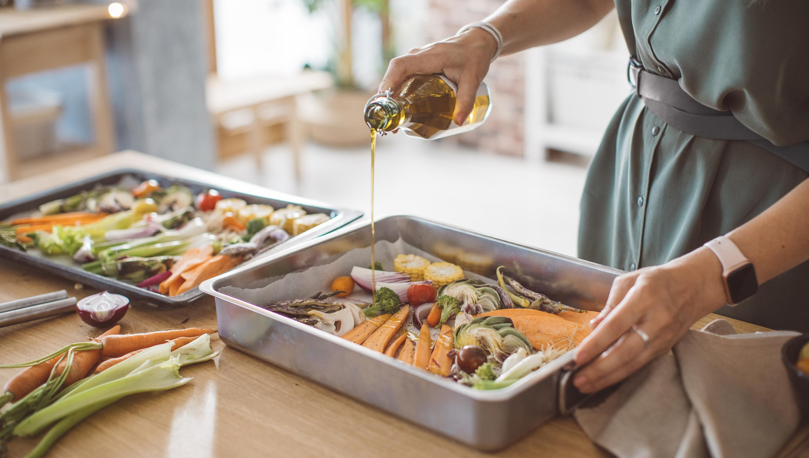

Sprint 1: User Stories/Product Backlog

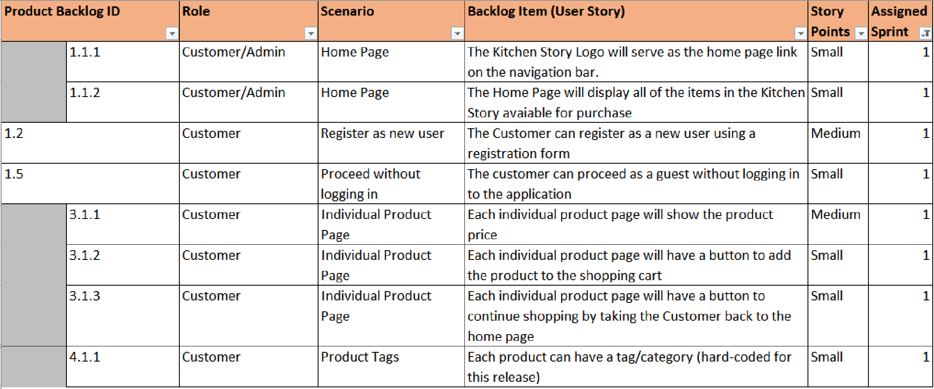



Sprint 2: User Stories/Product Backlog

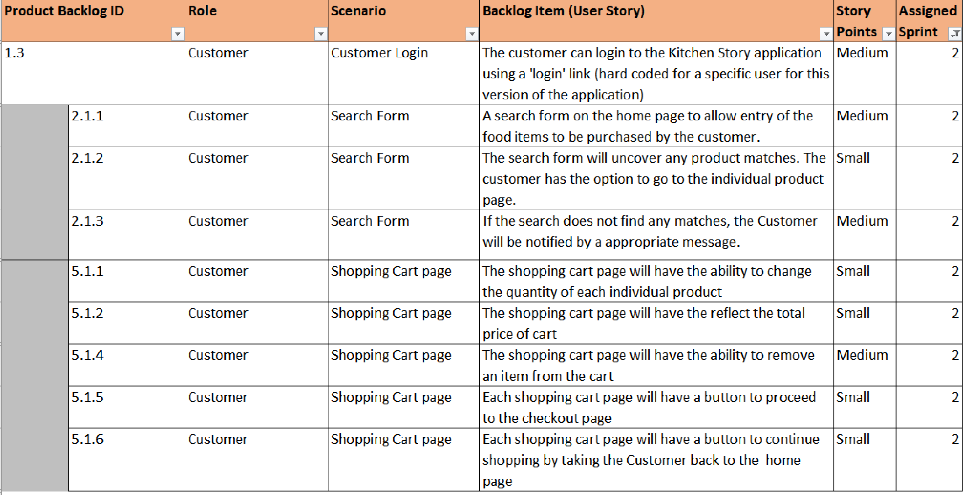



Sprint 3: User Stories/Product Backlog

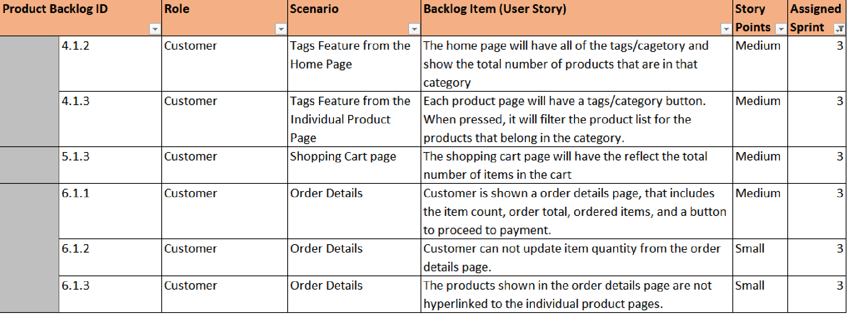



Sprint 4: User Stories/Product Backlog

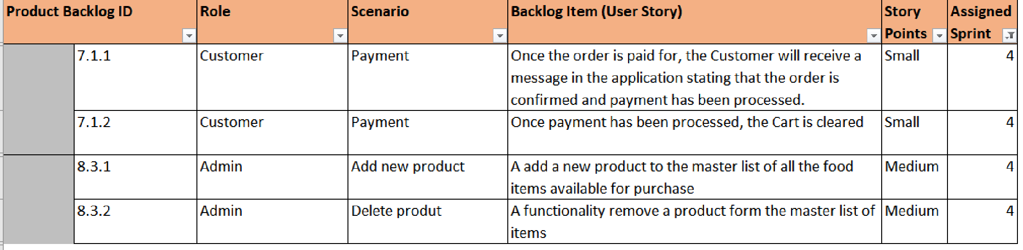

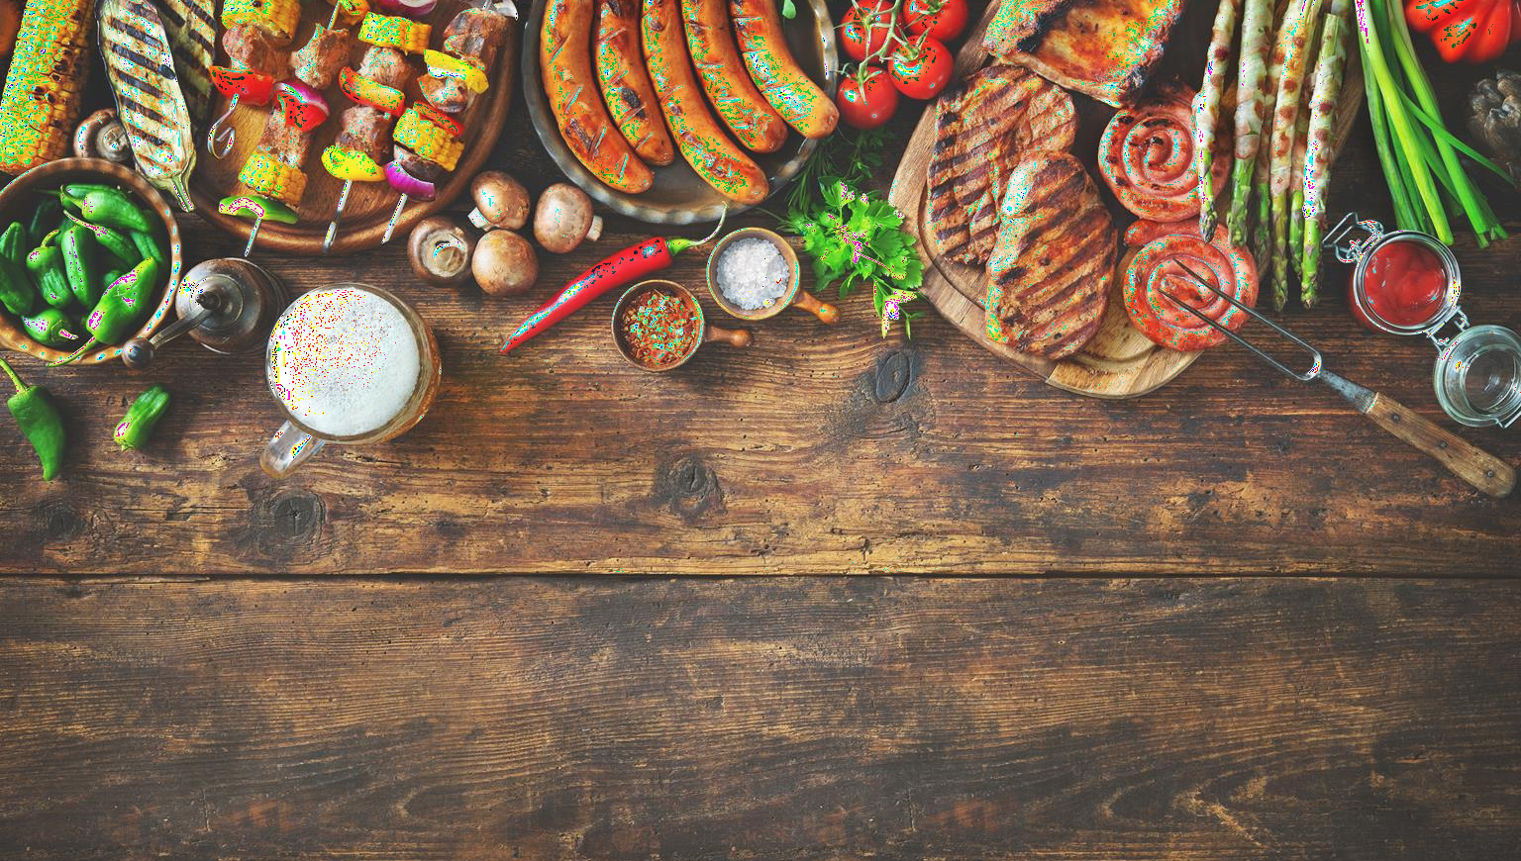

High Level App Design: Kitchen Story



**Nav Bar**

Search Bar

Product Listing/Search Results

**Footer**

High Level Program Flow

## Single Page Application

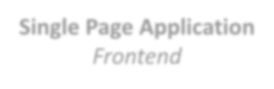

*Frontend*

Home Page

Login/Register Page

Search

Product

Cart

Checkout



Search by keyword

Add Product

Remove

Product

Payment

Show all products in Cart

Remove Product from Cart

Add Product to Cart

Get All

Products

Get Product

by ID

Search by category

*Backend*

*Will implement for Capstone Project*

JSON MySQL

  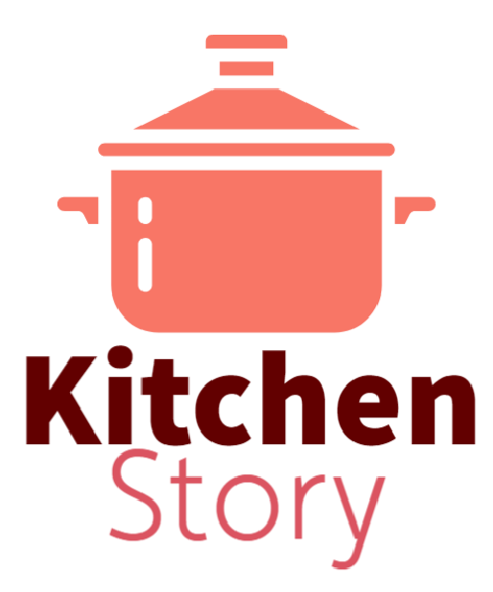

Kitchen Story App Logos

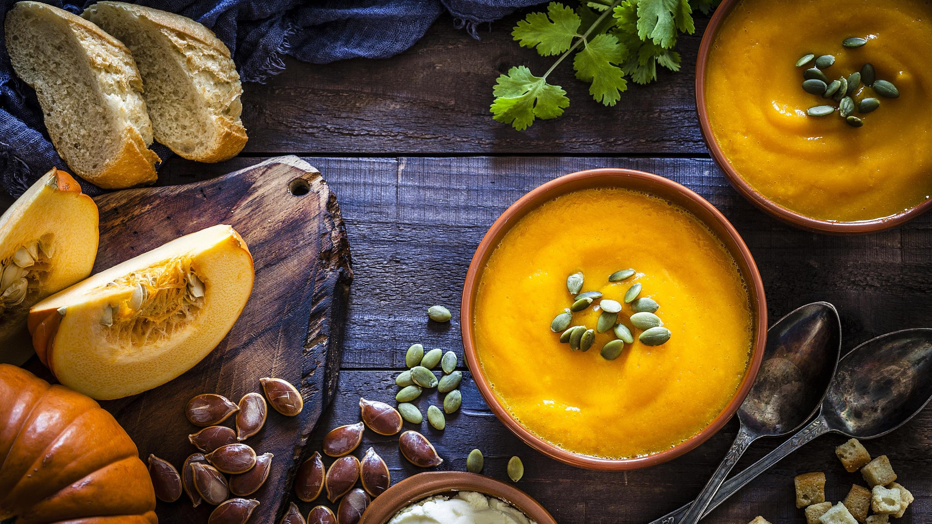



App Color Palette

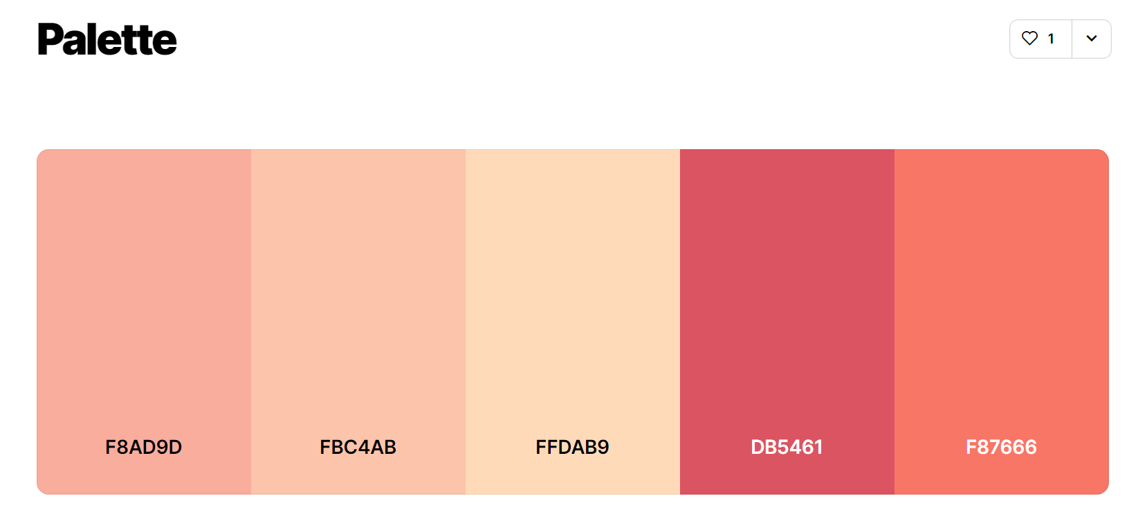

* <https://coolors.co/palette/f8ad9d-fbc4ab-ffdab9-db5461-f87666>